# The efficacy and safety of the Chinese herbalmedicine Di-Tan decoction for treating Alzheimer’sdisease: protocol for a randomized controlled trial

# 研究患者

Background: Alzheimer’s disease (AD) is the most common type of dementia in the elderly. It is estimated that the global prevalence of dementia will rise from 24.3 million in 2005 to 81.1 million in 2040. AD has a devastating impact on sufferers, caregivers, their communities and the healthcare system in general. “Di-tan decoction” (DTD) is a traditional Chinese medicine (TCM) formula frequently used to treat symptoms that are now defined as AD in clinical treatment. However, the existing evidence for recommending DTD in clinical practice derives from studies that were methodologically flawed. In this study, we aim to determine the efficacy and safety of DTD in AD patients based on a rigidly randomized controlled trial. It will provide critical information on sample size and treatment regimen for conducting a full-scale clinical trial of DTD later. Methods/Design: This study will be a double-blind, randomized, placebo-controlled, add-on trial. After a 2-week run-in period, eligible patients with mild to moderate AD will be recruited and given either DTD or placebo twice daily for 24 weeks with follow-up 6 weeks after the last treatment.

# 样本量

Recruitment procedures Three methods will be used to recruit participants with AD. The first source of candidates will be referral from two public Western medicine hospitals in Hong Kong (Prince of Wales Hospital and Queen Elizabeth Hospital) from our co-investigator (Co-I), V. Mok, and our research teammate, A.L.T. Chan. The second source will be referral from the Chinese medicine clinic of Hong Kong Baptist University. A third source of candidates will be those who respond to advertisements published in local newspapers and newsletters of local AD societies. Figure 1 shows the schedule of enrollment. We plan to recruit at least 40 patients, which will allow 20 for the DTD group and 20 for the placebo group in this study.

# 基线特征

# 试验设计

No Match

# 研究背景

Background  
Alzheimer’s disease (AD) is an irreversible, progressive neurodegenerative disorder characterized by loss of cog- nitive functions , behavioral disturbances and daily living difficulties [1]. It is the most common type of dementia in the elderly [2].

# 研究结果

results of another study indicate that DTD may inhibit the decline of the dopamine content in brain tissue of model mice as well [19]. In our previous systematic review, there was no clin- ical trial using DTD as the main intervention for treating AD.

# 研究结论

No Match

# 表格及图片陈述

>>>>>>>>>>>>>>>>>>

Study medication The herbal medicine under study is DTD (Table 1)

>>>>>>>>>>>>>>>>>>

Study medication The herbal medicine under study is DTD (Table 1)

# 表格及图片

## 表格

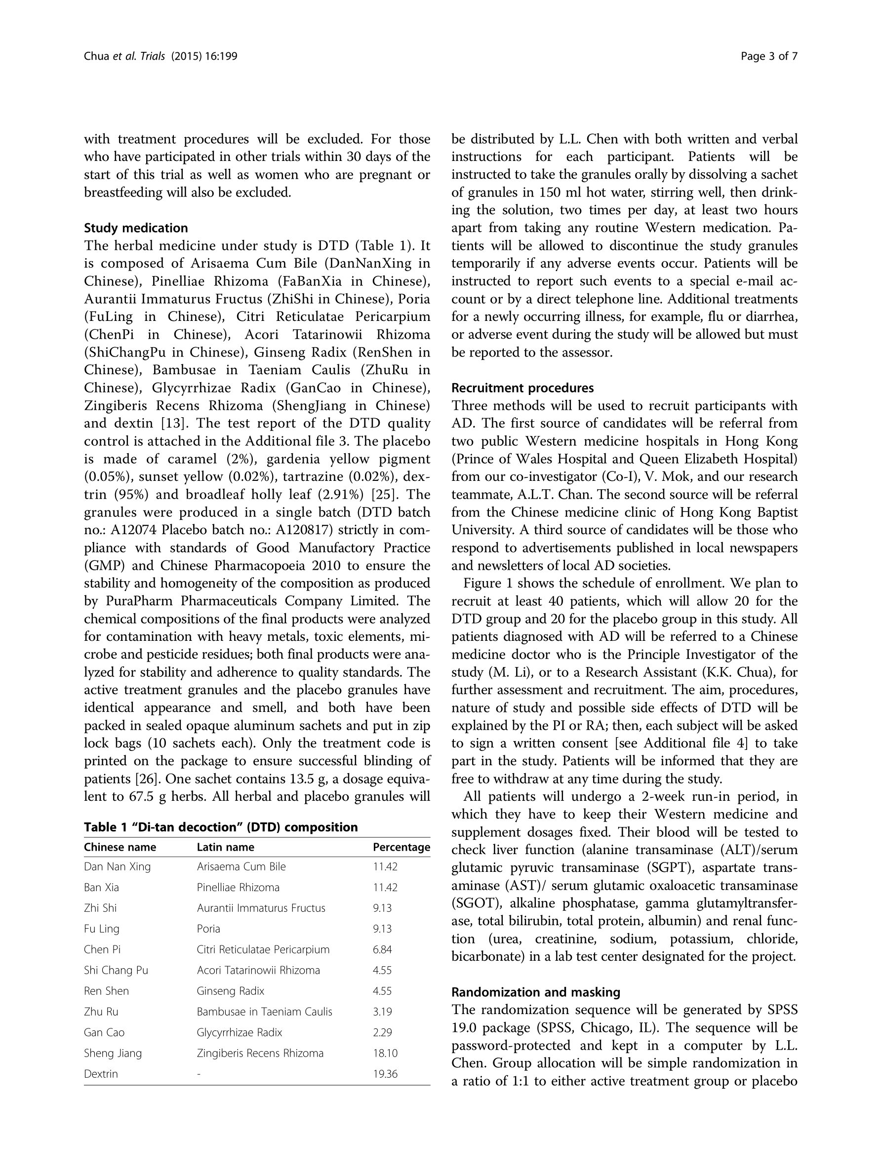

## 图片

